Muhammad fadillah

1207070075

DETEKSI TEPI (Edge Detection)

1. filter Sobel

import cv2

import numpy as np

from matplotlib import pyplot as plt

from skimage import data

img = data.astronaut()

#sobel

img_sobelx = cv2.Sobel(img,cv2.CV_8U, 1,0,ksize=5)

img_sobely = cv2.Sobel(img,cv2.CV_8U, 0,1,ksize=5)

img_sobel = img_sobelx + img_sobely

fig, axes = plt.subplots(4, 2, figsize=(10, 10))

ax = axes.ravel()

ax[0].imshow(img, cmap = 'gray')

ax[0].set_title("citra input")

ax[1].hist(img.ravel(), bins = 256)

ax[1].set_title("Histogran Citra Input")

ax[2].imshow(img_sobelx, cmap = 'gray')

ax[2].set_title("citra input")

ax[3].hist(img_sobelx.ravel(), bins = 256)

ax[3].set_title("Histogran Citra Input")

ax[4].imshow(img_sobely, cmap = 'gray')

ax[4].set_title("citra input")

ax[5].hist(img_sobely.ravel(), bins = 256)

ax[5].set_title("Histogran Citra Input")

ax[6].imshow(img_sobel, cmap = 'gray')

ax[6].set_title("citra input")

ax[7].hist(img_sobel.ravel(), bins = 256)

ax[7].set_title("Histogran Citra Input")

fig.tight_layout()

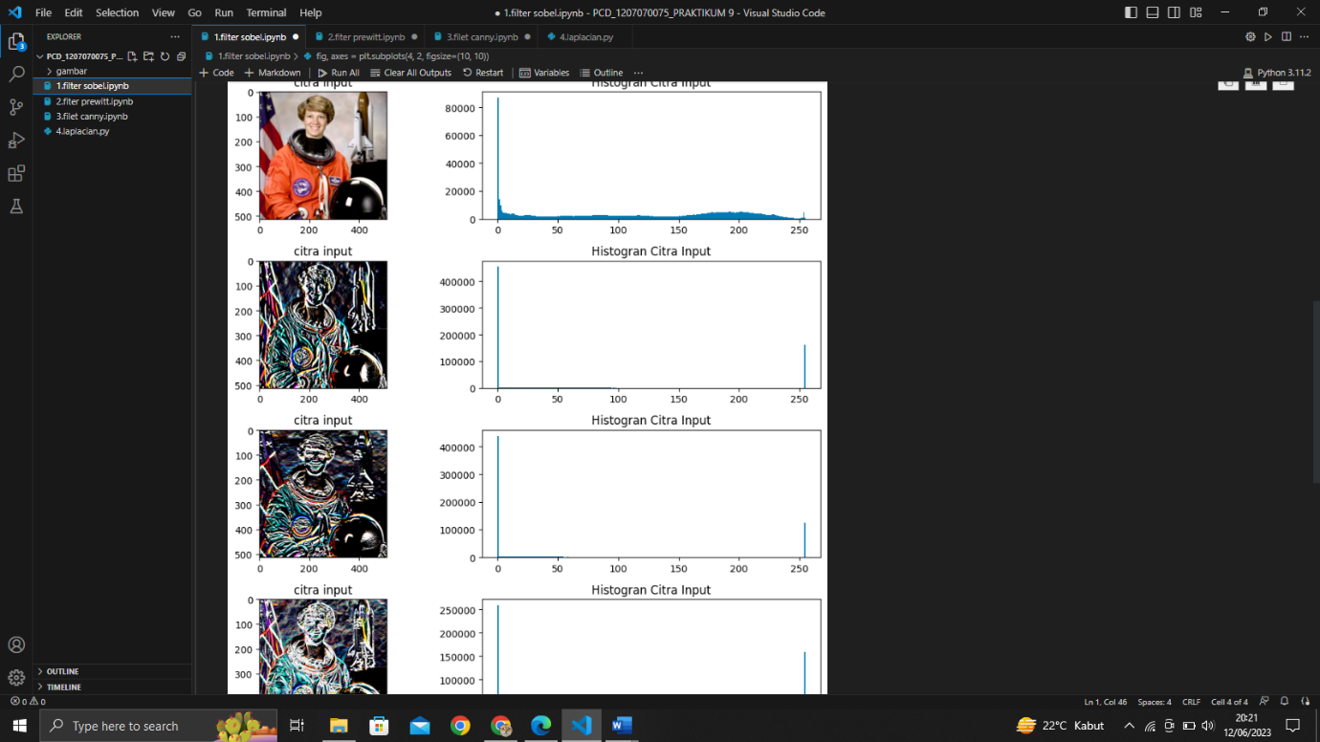

1. filter Prewitt

import cv2

import numpy as np

from matplotlib import pyplot as plt

from skimage import data

img = data.astronaut()

#prewitt

kernelx = np.array([[1,1,1,],[0,0,0],[-1,-1,-1]])

kernely = np.array([[-1,0,1,],[-1,0,1],[-1,0,1]])

img_prewittx = cv2.filter2D(img, -1, kernelx)

img_prewitty = cv2.filter2D(img, -1, kernely)

img_prewitt = img_prewittx + img_prewitty

fig, axes = plt.subplots(4, 2, figsize=(10, 10))

ax = axes.ravel()

ax[0].imshow(img, cmap = 'gray')

ax[0].set_title("citra input")

ax[1].hist(img.ravel(), bins = 256)

ax[1].set_title("Histogran Citra Input")

ax[2].imshow(img_prewittx, cmap = 'gray')

ax[2].set_title("citra input")

ax[3].hist(img_prewittx.ravel(), bins = 256)

ax[3].set_title("Histogran Citra Input")

ax[4].imshow(img_prewitty, cmap = 'gray')

ax[4].set_title("citra input")

ax[5].hist(img_prewitty.ravel(), bins = 256)

ax[5].set_title("Histogran Citra Input")

ax[6].imshow(img_prewitt, cmap = 'gray')

ax[6].set_title("citra input")

ax[7].hist(img_prewitt.ravel(), bins = 256)

ax[7].set_title("Histogran Citra Input")

fig.tight_layout()

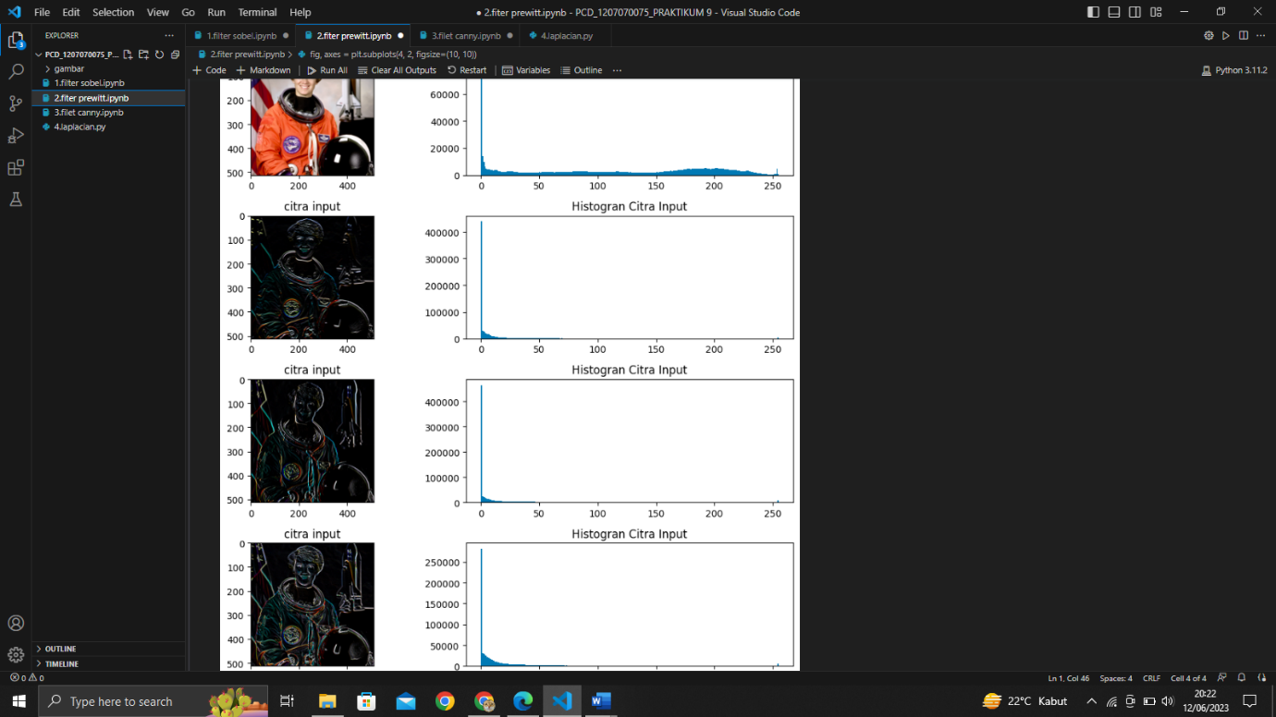

1. filter Canny

import cv2

import numpy as np

from matplotlib import pyplot as plt

from skimage import data

img = data.astronaut()

#canny

img_canny = cv2.Canny(img,100,200)

fig, axes = plt.subplots(2, 2, figsize=(10, 10))

ax = axes.ravel()

ax[0].imshow(img, cmap = 'gray')

ax[0].set_title("citra input")

ax[1].hist(img.ravel(), bins = 256)

ax[1].set_title("Histogran Citra Input")

ax[2].imshow(img_canny, cmap = 'gray')

ax[2].set_title("citra input")

ax[3].hist(img_canny.ravel(), bins = 256)

ax[3].set_title("Histogran Citra Input")

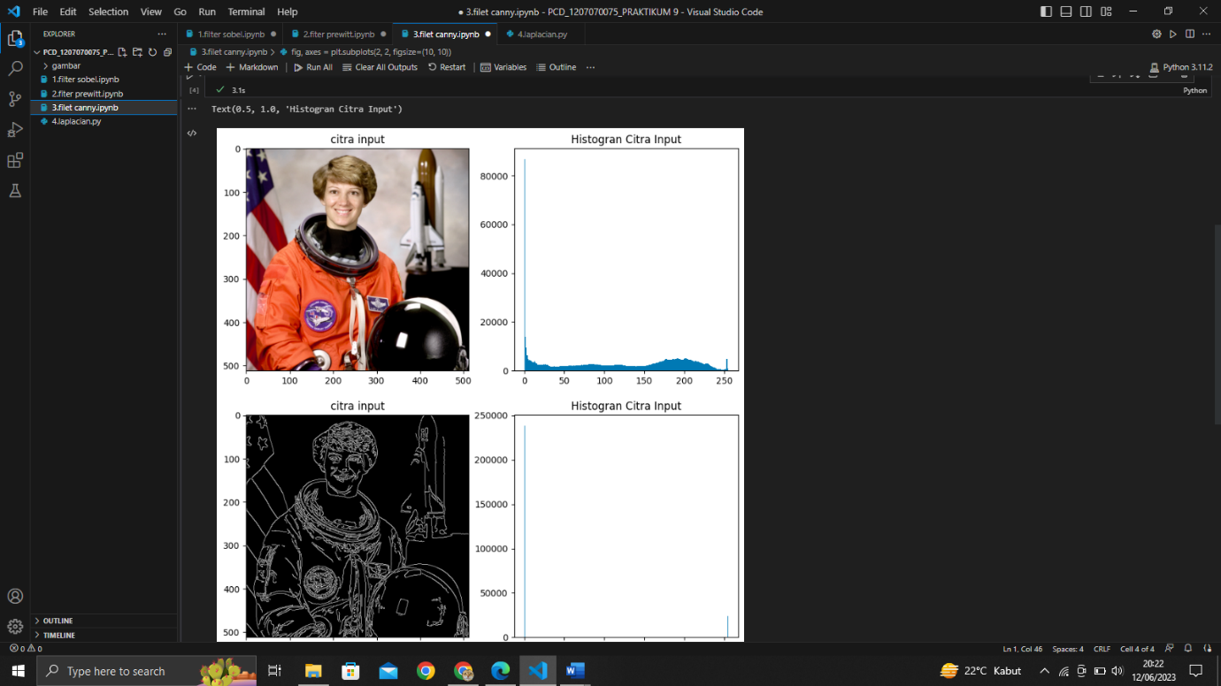

1. filter Laplacian

import cv2

img = cv2.imread('gambar/nicola.jpg', 0)

blur = cv2.GaussianBlur(img, (3, 3), 0)

laplacian = cv2.Laplacian(blur, cv2.CV_64F)

laplacian = laplacian / laplacian.max()

cv2.imshow('laplacian-gaussian', laplacian)

cv2.waitKey(0)

